Local RAG and Document Chat Application

- UI / Design Requirement
  - Use the attached screenshot as the main UI reference. The interface must look almost identical to ChatGPT
  - Left sidebar with chat history:
    - New chat button
    - Search chats option
    - Right-click to chat should give a menu to delete chat.
  - Main chat area with message bubbles:
    - Generative response should be streaming.
    - Generative response bubble should show animations like: Thinking, Generating, Uploading File n of X, Processing File n of X, Processed File n of X in sss Seconds.
  - Input box at bottom with file attachment button
    - Input Box start with 3 lines of active display.
    - Capability to grow till 10 Lines of active display.
    - The upload button should open multiple file selection window to select files to upload.
  - Top Right should give options to Ollama models downloaded.

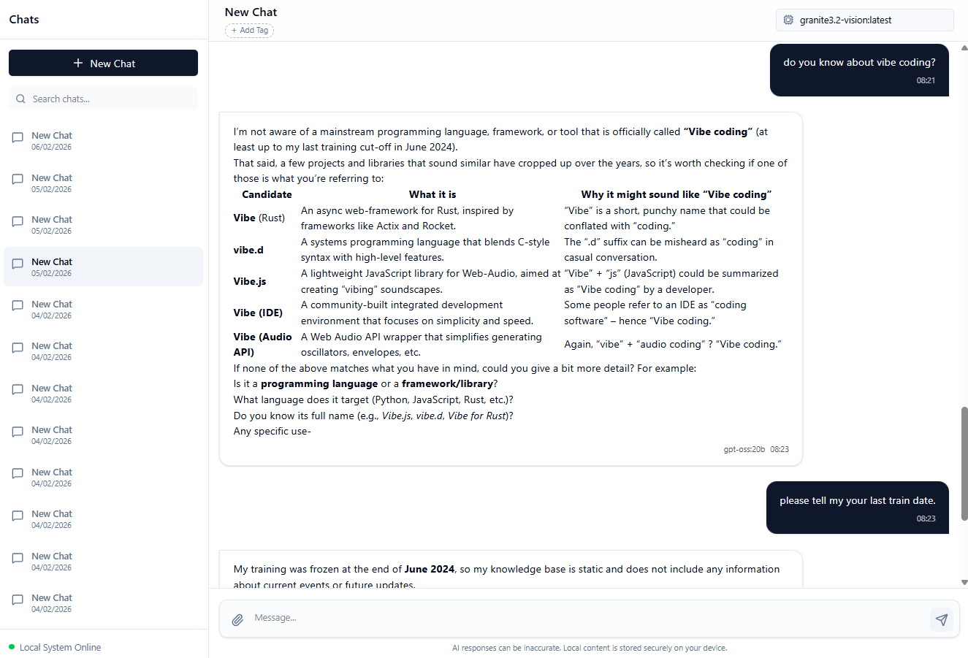

- Tech Requirements:
  - Docling (https://docling-project.github.io/docling)
    - To converter to convert messy documents into structured data.
    - Understanding for storing proper metadata, including page layout, reading order, table structure, code, formulas, and image classification.
    - Chunking implementation uses a hybrid approach (Postgres with vector DB to be used)
      - applying tokenisation-aware refinements on top of document-based hierarchical chunking:
      - hierarchical chunker and, based on the tokenizer (typically to be aligned to the embedding model tokenizer).
      - does one pass where it splits chunks only when needed (i.e. oversized w.r.t. tokens),
      - another pass where it merges chunks only when possible (i.e. undersized successive chunks with the same headings & captions)
    - Ollama’s nomic-embed-text Model to be used for embedding.
    - Tesseract OCR for scanned PDFs and images.
    - TableFormer (accurate) from docling-ibm-models should be used for Tables.
    - Visual Language Models: granite_vision with Ollama (The Docling pipeline allows for loading and running models completely locally)
      - Picture classification: The picture classification step classifies the Picture Item elements in the document with the DocumentFigureClassifier model. Specialised to understand the classes of pictures found in documents, e.g. different chart types, flow diagrams, logos, signatures, etc.
      - Picture description: The picture description allows for annotating a picture with a vision model. This is also known as a "captioning" task.
  - All chat conversations to be stored in MS SQL Server DB.
    - Last 5 chats to be retrieved and summarised by LLM and be presented to LLM with a user Prompt when a chat session is resumed to maintain the context.
    - Subsequent chat messages sent to the LLM will have context, so it's not necessary to summarise and set the context with each message.
    - Fresh chat message should carry an appropriate system message to guide the LLM.
  - All document meta tags to be stored in MS SQL Server, and embedding and Vector data to be stored in Postgres.
  - LLM, which has thinking, should also be streamed to the chat bubble section, as an example, GPT-oss has thinking capability shown in the following screenshot. This thinking should be shown in light Gray bubble in chat UI section.

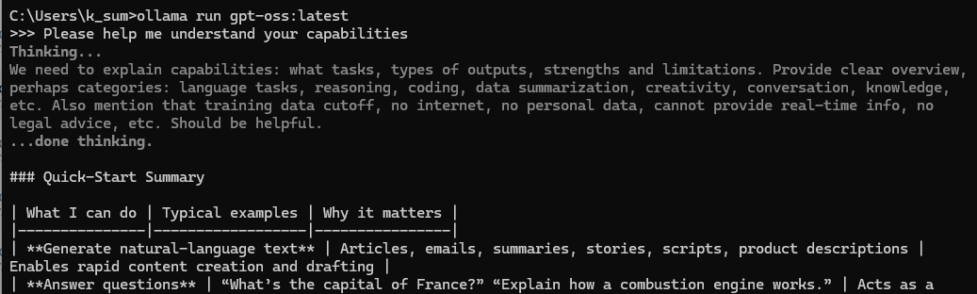

  - We have 3 contexts here, namely: LLM’s own Training data, Chat Context, and Document Context. We need to define which context should receive the greatest consideration. Let’s take an example. I uploaded a file named DDF.pdf. This file is in Hindi. And has nothing to do with DDF Limited(company). The following Image shows the conversation. Instead of generating the text from the file uploaded, LLM starts answering from its own training data, AKA Hallucination. To avoid this Let us make a Right Sidebar. In this sidebar, we will have 2 sections.
    - Section 1:
      - A toggle for LLM’s Data. If switched off, then we will append to the user prompt a instruction that tells LLM not to use its own data to answer the question and strictly use past chat and documents listed in the lower section of the Right Sidebar
      - A toggle for Documents. If switched off, then the vector DB will be bypassed. A prompt with past chat context will be sent to the LLM to generate an answer.
      - A toggle for Internet Search. If switched on, we can get the LLM to FIRST generate some contextual words for web search based on the prompt and/or the document chunks retrieved from the vector DB (if any, limited to 10 words). This web search can be done using Ollama api. https://ollama.com/api/web_search. Text will be extracted from a web search, appended to the prompt and document chunks retrieved from the vector DB, and given to the LLM to generate an answer.
    - Section 2:
      - This will have a search box and a list view with under it.
      - Based on the prompt, and if the document toggle is on, it will search the vector DB, pull out relevant text to append to the prompt, and then give this prompt to LLM for the generation of an answer. If document toggle is off, then vector DB will be bypassed.
